Spectral Estimation
7.2 Analysis of Windowing Effects on Spectral Estimation Using Rectangular, Hamming and Hanning Windows in MATLAB
Program (MATLAB Code)
clc; clear; close all;
% Signal
fs = 1000; N = 256; t = (0:N-1)/fs;
x = sin(2*pi*100*t) + 0.8*sin(2*pi*110*t);
NFFT = 2048; f = (0:NFFT/2-1)*(fs/NFFT);
% Windows
w = {rectwin(N), hamming(N), hann(N)};
names = {'Rectangular','Hamming','Hanning'};
% Processing
for i = 1:3
xw = x(:).*w{i};
X = fft(xw,NFFT);
P{i} = abs(X(1:NFFT/2));
P{i} = P{i}/max(P{i});
end
%% Individual Spectrums
figure;
for i = 1:3
subplot(3,1,i);
plot(f,20*log10(P{i}),'LineWidth',1.5);
title(['Spectrum using ' names{i} ' Window']);
xlim([0 250]); grid on;
end
%% Comparison
figure;
plot(f,20*log10(P{1}),'k',f,20*log10(P{2}),'r',f,20*log10(P{3}),'b','LineWidth',1.5);
legend(names); title('Window Comparison'); xlim([50 170]); grid on;
%% Window Shapes
figure;
for i = 1:3
subplot(3,1,i); plot(w{i},'LineWidth',1.5);
title([names{i} ' Window']); grid on;
end
%% Peak Detection
for i = 1:3
[pks{i},loc{i}] = findpeaks(P{i},f,'MinPeakHeight',0.3);
fprintf('\n%s Window Frequencies:\n',names{i});
disp(loc{i});
end
%% Peak Marking (Hamming)
figure;
plot(f,20*log10(P{2}),'LineWidth',1.5); hold on;
plot(loc{2},20*log10(pks{2}),'ro','MarkerFaceColor','r');
title('Detected Frequencies (Hamming)'); xlim([50 170]); grid on;
%% Main Peaks
fprintf('\nMain Spectral Peaks:\n');
for i = 1:3
[~,idx] = max(P{i});
fprintf('%s Window Peak = %.2f Hz\n',names{i},f(idx));
end

Output
Main Spectral Peaks:
Rectangular Window Peak = 100.10 Hz
Hamming Window Peak = 100.10 Hz
Hanning Window Peak = 100.10 Hz

Fig 1
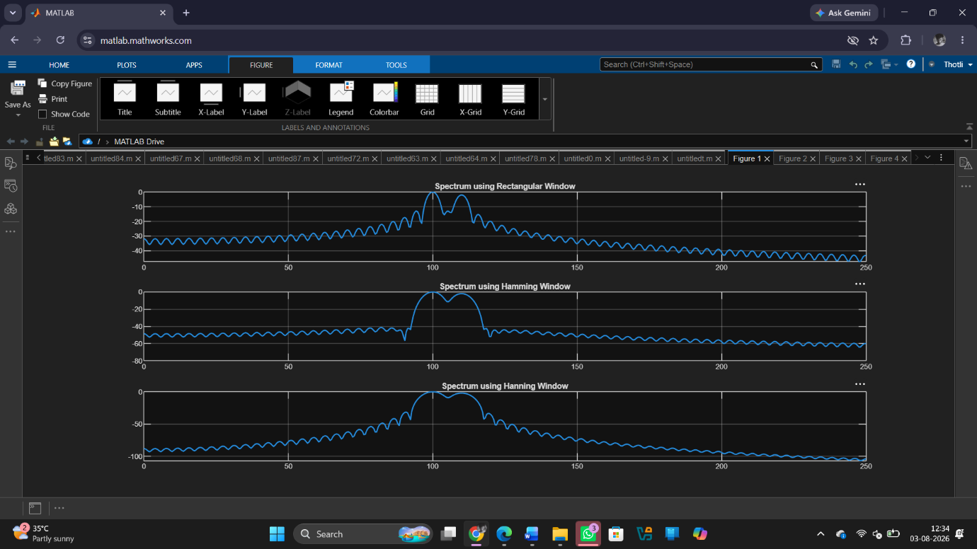
Fig 2
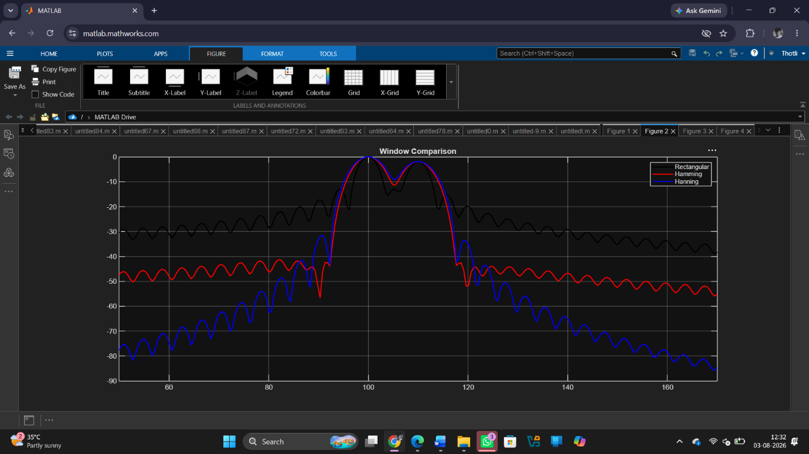
Fig 3
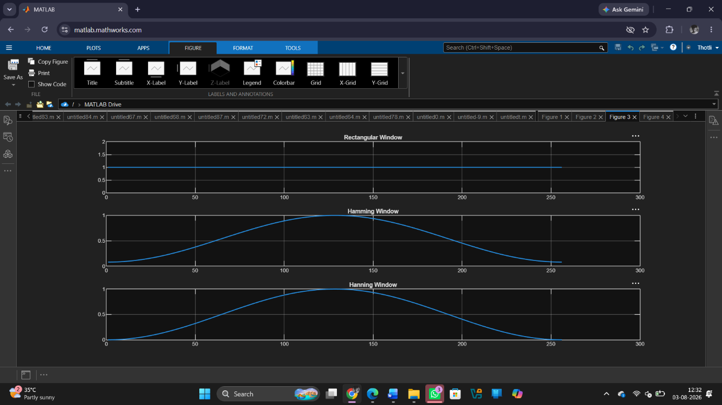
Fig 4
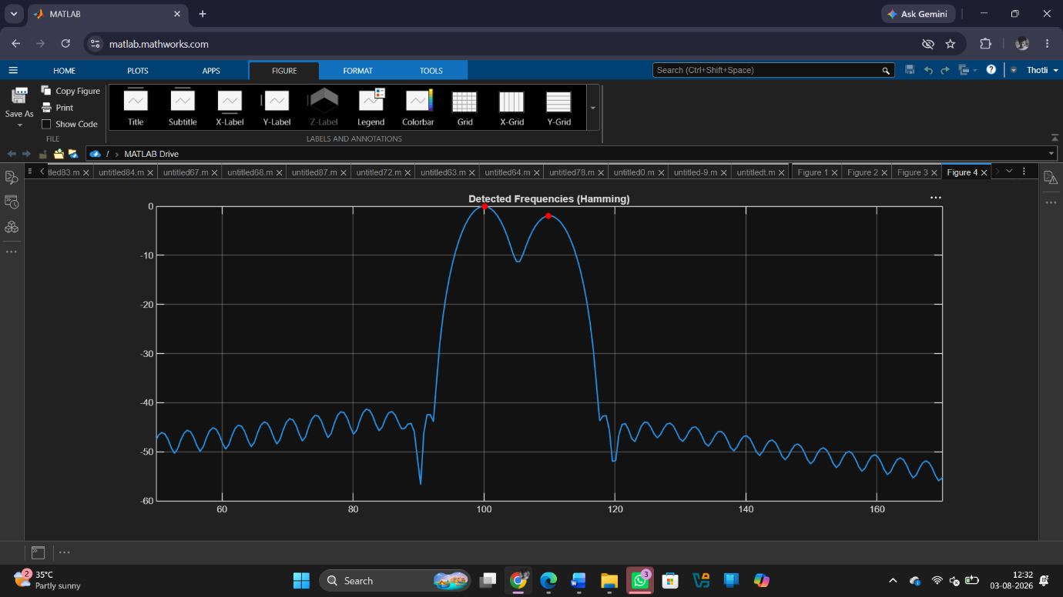

Result
1. The spectrum of the given signal was successfully estimated using Rectangular, Hamming, and Hanning window functions in MATLAB.
2. The effect of window selection on spectral leakage was analysed, showing that the Rectangular window exhibits higher leakage compared to Hamming and Hanning windows.
3. The main-lobe width and side-lobe levels were compared, where Hamming and Hanning windows provided better side-lobe suppression at the cost of slightly wider main-lobes.
4. The accuracy of frequency component detection was evaluated, and it was observed that windowing improves frequency resolution and reduces spectral distortion.

